**Practical E.1**

Aim – Write a program for creating student beans. Display properties of a bean using JSP.

Code:-

<%@ **page** language=*"java"* contentType=*"text/html; charset=ISO-8859-1"*

pageEncoding=*"ISO-8859-1"*%>

<!**DOCTYPE** html>

<**html**>

<**head**>

<**meta** charset=*"ISO-8859-1"*>

<**title**>Insert title here</**title**>

</**head**>

<**body**>

<**jsp:useBean** id=*"student"* scope=*"page"* class=*"pkg.Students"*/>

<**jsp:setProperty** name =*"student"* property=*"rollno"* value=*"53"*/>

<**jsp:setProperty** name =*"student"* property=*"name"* value=*"Pavan"*/>

<**jsp:setProperty** name =*"student"* property=*"marks"* value=*"85"*/>

<**pre**>

STUDENT

Roll Number : <**jsp:getProperty** name =*"student"* property=*"rollno"*/>

Name : <**jsp:getProperty** name =*"student"* property=*"name"* />

Marks : <**jsp:getProperty** name =*"student"* property=*"marks"* />

</**pre**>

</**body**>

</**html**>

Output:-

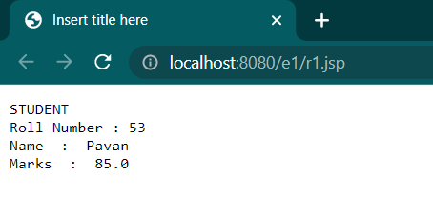

**Practical E.2**

Write a java program for encoding JSON.

Code:-

import java.io.FileWriter;

import java.io.FileWriter;

import java.util.Scanner;

import org.json.*;

import org.json.simple.JSONObject;

public class E2 {

public static void main(String[] args) {

Scanner sc=new Scanner(System.***in***);

System.***out***.print("Enter Student Name");

String n=sc.next();

System.***out***.print("Enter Your roll no");

double roll=sc.nextDouble();

System.***out***.print("Enter your Marks");

double mks=sc.nextDouble();

JSONObject obj = new JSONObject();

obj.put("Name", n);

obj.put("Roll no", roll);

obj.put("marks", mks);

System.***out***.print(obj);

try {

System.***out***.print("\nWritting Date into JSONfile...");

FileWriter fw = new FileWriter("d:/encode.jsn");

fw.write(obj.toJSONString());

fw.close();

System.***out***.print("Done");

} catch (Exception e) {

System.***out***.print(e);

}

}}}

}

}

Output:-

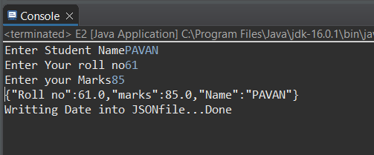

**Practical E.3**

Aim – Write a java program for decoding JSON.

Code:-

import java.io.FileReader;

import org.json.simple.JSONObject;

import org.json.simple.parser.JSONParser;

public class E3 {

public static void main(String args[])

{

JSONParser parser = new JSONParser();

try {

Object obj = parser.parse(new FileReader("d:/encode.jsn"));

JSONObject ob = (JSONObject)obj;

String n = (String) ob.get("Name");

double roll = (double)ob.get("Roll no");

double m = (double)ob.get("marks");

System.***out***.println("Name:"+n);

System.***out***.println("RollNo"+roll);

System.***out***.println("Marks"+m);

}

catch (Exception e) {

System.***out***.println(e);

}

}

}

Output:-

